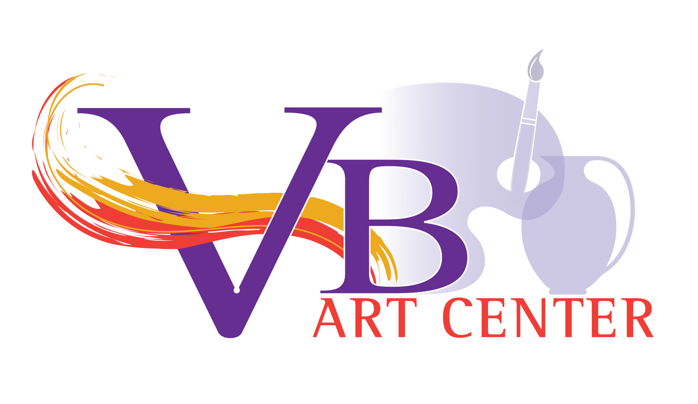

**Class Proposal Form**

Please complete this form for each class that you propose to teach at the Virginia Beach Art Center. Use as much space as you need. Remove examples typed in blue and fill in your information. The final details of the class will be mutually agreed upon with the manager who is responsible for class scheduling.

Instructor Name:

Instructor Phone:

Instructor Email:

Instructor Address:

Instructor Website:

Instructor Social Media Handles:

**Proposed Class Information:**

Class Name: Please provide a suggested class title. It may include your name if desired. Think of something catchy that will pique interest.

Primary Media: Media, primary techniques, or subject matter that will be taught.

Learner Skill Level: List all learner levels you are willing to accommodate (beginner, intermediate, advanced) or any specific skills that are required as a prerequisite. If multi-level, explain how you will be able to address the needs of different levels in the class.

Class Size: Indicate the minimum and maximum number of students you are willing to accommodate.

Age Range: List the youngest age (or grade level) you are willing to accept. If proposing to teach children, indicate if an adult needs to remain on the premises or participate in the class with their children. Instructors with students who are under the age of 18 must undergo a background check.

Location: _____Virginia Beach Art Center _____Online (i.e., via zoom) _____Other Location.

Explain Other location: Address and title of location, why the class is better suited there, any costs or considerations for use of another location.

Class Session Duration: Number of sessions and number of hours in each session (i.e., 4 weekly sessions, 3 hours each).

Proposed Cost for the Class: Total student cost should include any fees for instructor-provided supplies (which can be explained in the class description). The Art Center reserves the right to determine the final cost for the class.

**Instructor Availability/Requested Dates and Times:**

Start Date: Indicate the earliest date you are be available to start classes. The actual start date will be adjusted in the to a mutually agreeable date when the overall schedule is created.

End Date: Indicate the date by which you would need to end your class.

Day(s) of the Week: Indicate the day or days of the week that you are available. Flexibility with days of the

week and morning/afternoon/evening preference allows the managers to fit your proposal into the schedule.

Start Time: List all times you are available to start on any given day.

End Time: List the latest time that you must be finished on any given day.

**Class Information to be Published:**

Class Description:

Provide a description of your proposed class to be published on the class registration page. This description should sell the class, include what students will learn and what outcomes they should experience.

Supply List:

Provide a detailed list of any supplies that the students must bring to class, and a list of supplies that will be provided by the instructor. This will be published on the class registration page. If pottery instructors request a specific clay or glaze that is not currently supplied by VB-AC, they must clear that with the Pottery Manager.

**Instructional Plan (not published):**

Lesson Plan

Objectives: List the outcomes the students will achieve during your class.

Activities/Class Outline: Include introduction, key concepts that will be covered each week, and how the session will be summarized.

Instructional Techniques: Explain the instructional techniques you plan to use, including demonstration, lecture, student practice, student assistance, instructional videos, website resources, follow up, etc.

**Images:**

Please include a .jpeg image or images of the type of artwork that you are planning to teach, an example of a typical student outcome and/or a picture of you teaching.

**Orientation and Paperwork:**

All paperwork and a New Instructor Orientation are required before classes begin. Art and Pottery Managers routinely visit and observe classes to ensure high quality of education and instruction at the Art Center.

Instructor Signature: __________________________________ Date: ____________________

VB Art Center Signature: _______________________________ Date: ____________________